**The effect of inter-tillage weeding on rice yield, growth and nutrient dynamics without agricultural chemicals and fertilizers**

Zhiduo Zhou1, Yan Zhu1, Munehide Ishiguro2, Junichi Kashiwagi2 and Araki Hajime3

1Graduate School of Agriculture, Hokkaido University

2Research Faculty of Agriculture, Hokkaido University

3Niigata Agri-food University

Inter-tillage weeding was a traditional way to remove weeds without chemicals. Kasubuchi (2019) succeeded in getting a high yield in paddy fields by introducing inter-tillage without agrochemicals and fertilizers in Japan. The objective of this study is to clarify the effect of five times inter-tillage weeding on rice yield and nutrient dynamics in Hokkaido.

From 2018 to 2022, there are four treatments: no inter-tillage weeding (0-T), 2-time inter-tillage weeding (2-T), 5-time inter-tillage weeding (5-T), and conventional cultivation (CF). In 2022, three frames (CI) were set in inter-tillage field with agrochemical and fertilizer applications.



Figure.1. Brown rice yield from 2018 to 2022

As shown in Fig.1, in 2018, after several years’ fallow, the yields of inter-tillage fields (IF) were all higher than that of the regional average yield but decreased a lot in 2019 due to the fertility decrease. Compared with 2019, after several years’ cultivation without agricultural chemical and fertilizers, the difference between regional average and inter-tillage fields became smaller in 2022. Meanwhile, the yields in 2-T and 5-T were significantly (P < 0.05) higher than that in 0-T, and the yields in 2-T and 5-T were significantly higher than those in 2019. Significant difference among 2-T, 5-T and CI was not observed. From 2020 to 2022, the yield showed significant negative correlation with weed biomass during whole growth period in inter-tillage field. Inter-tillage weeding could improve yield by controlling weed biomass effectively.

As shown in Fig.2 and Fig.3, from 2018 to 2020, NH4+-N concentration in soil solution and exchangeable NH4+-N concentration in soil solution at around 5 cm depth decreased year by year in inter-tillage fields, and then recovered from 2020 to 2022. In 2022, the NH4+-N concentration in soil solution in inter-tillage fields already reached the same level as that in 2018. Meanwhile, the nitrogen concentration in rice straw during tillering stage, panicle formation stage, and heading stage showed the same trend as NH4+-N concentration in soil and soil solution, which decreased yearly from 2018 to 2020 but increased yearly after 2020.

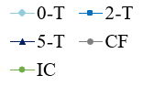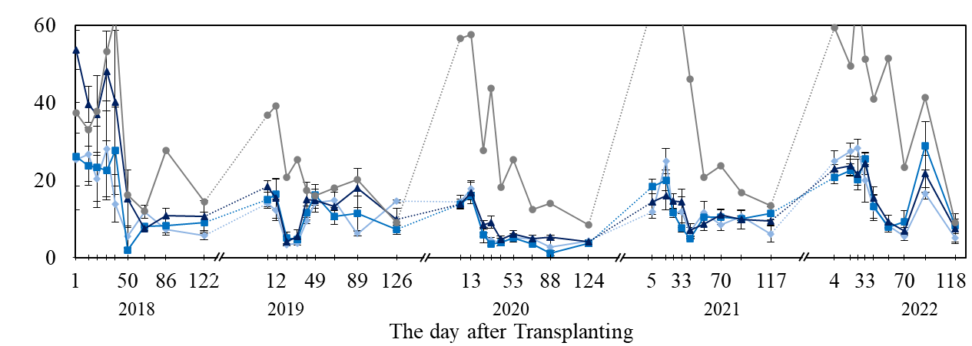

Figure.3. Exchangeable ammonium nitrogen concentration in soil at 5 cm depth

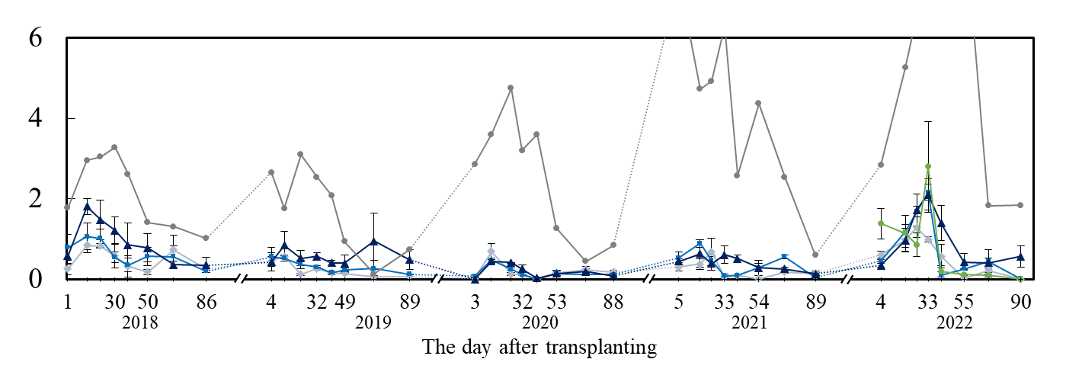

Figure.2. Ammonium nitrogen concentration in soil solution at 5cm depth



After five years of agrochemical-free and fertilizer-free cultivation, the potassium and phosphorus deficiency were still not founded in inter-tillage fields. Although the significant effect of inter-tillage on nutrient dynamics was not observed, the results indicated that it is possible to improve soil fertility without any agrochemicals and fertilizers application.

**Key words:** Rice production; Inter-tillage weeding; Agrochemical-free and fertilizer-free; Nutrients dynamics

**References：**

Kasubuchi, T., H. Arao, H. Yasuda (2019) Warning for modern agriculture depending on chemical fertilizers and agricultural chemicals; Significance of the multiple-inter tillage-weeding method developed in Edo-era. J. Jap. Soc. Soil Physics, 65-69.

Co-responding author: Yan Zhu

Position: Ph.D. student

Affiliations: Graduate School of Agriculture, Hokkaido University

Country: Japan

E-mail: ZhuY_1998@outlook.com